Title of the policy brief
20 October 2026

Takeaways
3-5 Bullet points on:
- a description of the problem addressed
- a statement on why the current approach/policy needs to be changed
- your recommendations for action

Introduction
Leave your readers with a clear sense of what your research is about while enticing them to continue reading.
In one or two paragraphs, define why you are writing the brief and express the urgency and importance of the topic to your audience.
Describe the problem that your policy recommendations intend to solve. Convince the target audience that a current and urgent problem exists which requires them to take action. What are we talking about? Which developments have caused this issue to be of particular relevance right now?

What science tells us
Research RESULTS: paint a general picture of the research findings before moving on to the specifics.
IMPLICATIONS are the effects that the research could have in the future. They are a soft but persuasive approach to describe the potential consequences of particular policies.
Think of the conclusion as a mirror to your introduction: you are once again providing an overview of your argument, but this time you are underlining its strength rather than introducing it.
TEXT
TEXT
TEXT
TEXT

TEXT

TEXT

TEXT

Box heading
Box text
(feel free to place this box anywhere in the document or remove it)
-
-
-

TEXT
TEXT
TEXT
TEXT
TEXT
TEXT
TEXT
TEXT
TEXT
TEXT
TEXT
TEXT
TEXT
TEXT
Figure 1: Name of illustration, source [1] (there must be at least one-two data visualisations or illustrations in the document)
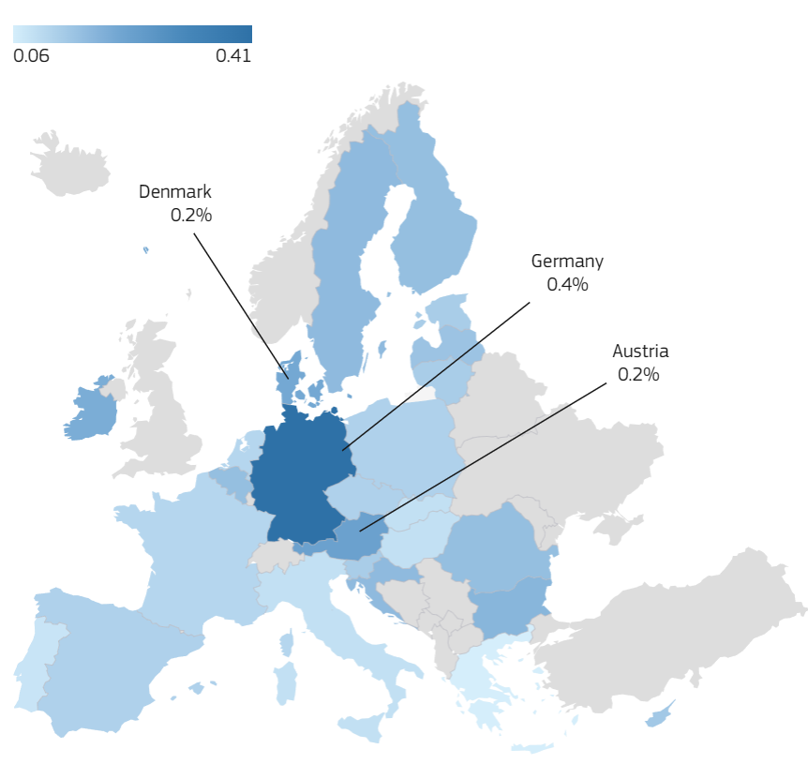
Tips:
Avoid jargon and overly technical language
Focus on highlighting the benefits and opportunities stemming from solving the focused problem using the presented research
Interpret the data in a way that is accessible and clearly connected to your policy advice.
Express ideas using active language and strong assertions.
Explain the findings and limitations of the research.
Express research findings in terms of how they relate to concrete realities (instead of theoretical abstractions).

Policy implications
Draw the link for your readers between the research findings and your recommendations.
Start with policy RECOMMENDATIONS. Beyond being descriptive, your recommendations should act as a call to action by stating precise, relevant, credible, and feasible next steps.
TEXT
TEXT

TEXT

TEXT

TEXT

TEXT

TEXT
TEXT
TEXT
TEXT
TEXT
TEXT
TEXT
TEXT
TEXT
TEXT

References
[1] Greenall, J. S., Cornu, L., Maigrot, A.-L., De La Torre, M. P., & Briefer, E. F., (2022), Age, empathy, familiarity, domestication and call features enhance human perception of animal emotion expressions, Royal Society Open Science 9, 221138 doi: 10.1098/rsos.221138.
[2] GreenState, (2024), What is Modular Farming? – Agriculture 2.0, https://greenstate.ch/blog-posts/modular-farmingagriculture- 2-0/.
[3] Guan, Y., Yan, J., Shan, Y., Zhou, Y., Hang, Y., Li, R., Liu, Y., Liu, B., Nie, Q., Bruckner, B., Feng, K., & Hubacek, K., (2023), Burden of the global energy price crisis on households, Nature Energy 8, 304–316 doi: 10.1038/s41560-023- 01209-8.
[4] Guerra, S., (2020), Brexit: The EU27’s Momentary Lapse of Unity, Political Insight 11, 34–36 doi: 10.1177/2041905820933374.

Authors: Team 1

